Mason Renfroe

Mrs. Rossi

Art 2

20 May 2019

Pablo Picasso

Born in 1881, Pablo Picasso was a well known Spanish painter who also sculpted, did printmaking, ceramics and stage designing. Picasso’s early paintings can be divided into two specific periods, the Blue Period from 1901 to 1904, and the Rose Period from 1904 to 1906. Along with Georges Braque, he created the Cubism movement which uses geometric shapes to make abstract art. His first Cubist painting from 1907 was “Les Demoiselles d’Avignon.” Cubism was most popular in the early 20th century but the style has influenced many other artists to experiment with their work. After 1917, Picasso began to use more realism in his paintings though Cubism reappeared over the years. During the course of his artistic career, Picasso constantly changed his style so his portfolio seems like a combination of multiple great artists instead of just a single one.
Picasso’s style and techniques varied quite a lot. In his first Cubist painting, “Les Demoiselles d’Avignon,” Picasso created the composition first with oil paint instead of putting his sketches on the canvas with pencil. Additionally, he outlined areas in dark paint filling in with parallel strokes with a loaded brush which is known as the Impasto Technique. It has also been discovered that Picasso actually used house paint in some of his pieces rather than regular artist’s paint. Doing this, he was able to hide brush marks and have a glossy style. An example of this technique is seen in “The Red Armchair (1931).” It is believed that he experimented with house paint because he wanted different effects that couldn’t be achieved with traditional oil paint. Whereas oil paint dries slowly, house paint dries quickly and you can see marbling, drips of paint and muted edges.
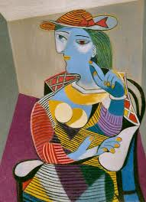
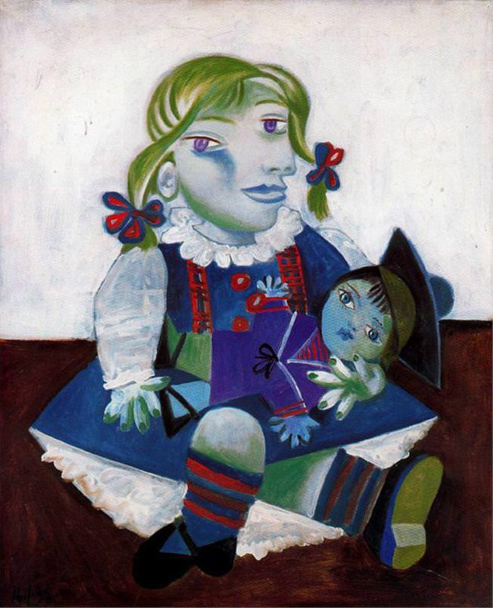
Two artworks I liked by Picasso are “Seated Woman” (1937) and “Maya with her Doll” (1938). In “Seated Woman,” the female figure is painted using bright colors. Picasso chose red and green polarization for dimension and black/white striations for the pattern on her body. Cubism is evident in her geometrically shaped dress and chair as well as her oddly shaped face and fingers. “Maya with her Doll” is a painting of Picasso’s own young daughter. The face of the little girl is distorted while the doll’s face is realistic. The girl’s legs are crossed in a bizarre way and her fingers holding the doll are unusually bent. Again, Picasso uses bright colors against brown and white. This piece shows less geometric features than his other Cubist work.

Works Cited
https://www.biography.com/artist/pablo-picasso
https://www.history.com/topics/art-history/history-of-cubism
https://www.livescience.com/26963-picasso-house-paint-x-rays.html
https://www.moma.org/collection/about/conservation/demoiselles/history_2_c.html
https://www.pablopicasso.org/seated-woman.jsp
https://www.pablopicasso.org/maya-with-her-doll.jsp

